OEM to itarang
OEM to iTarang Procurement Lifecycle Digitization:

Overview: Itarang’s OEM procurement today is fragmented across email and WhatsApp, causing pricing mismatches, reconciliation errors, delayed GRNs, weak asset traceability, and audit risk.
This BRD proposes a CRM-led, end-to-end procurement workflow that establishes a single system of record linking Orders, PI, Invoice, Payment, Delivery, GRN, and Inventory—while continuing to use email/WhatsApp as communication channels in Phase 1.
The outcome: faster procurement cycles, zero missing documents, accurate inventory, reduced disputes, and improved OEM trust.

Problem Statement: OEM procurement at Itarang is currently managed via email and WhatsApp with no system-level linkage between:
- Provisional Order
- PDI
- Order
- Proforma Invoice (PI)
- Invoice
- Payment
- Delivery
- GRN
- Inventory
This results in:
- Pricing and quantity mismatches during reconciliation
- Assets health and issues in other functionalities
- Delayed payments and OEM disputes
- Inaccurate or delayed inventory
- High manual effort during audits and compliance checks
Business Impact
- Poor working capital efficiency due to delayed GRNs and payment disputes
- Inventory inaccuracy impacting downstream sales and service
- Elevated audit and compliance risk
- Reduced OEM trust and negotiation leverage

Business Goal:
- Reduce procurement reconciliation - Eliminate pricing and quantity mismatches through system linkage
- Reduce average procurement TAT (Order → GRN)
- Achieve 100% traceability from OEM order to GRN
- Improve audit readiness (Zero missing documents; complete approval & edit logs)

User Goal:
- single place to track order status and dependencies
- Clear visibility into bottlenecks and escalations
- Finance can reconcile invoice ↔ payment ↔ GRN without spreadsheets
- Inventory team sees real-time inbound assets
- Accurate serialized and non-serialized inventory updates

Non-Goal:
- No OEM system integrations in Step 1 (email/WhatsApp only)
- No dealer/customer lifecycle tracking in this phase
- No automated payment execution beyond recording & tracking

Scope:
- OEM → Itarang procurement lifecycle
- Provision → PI → Invoice → Payment → Delivery → GRN → Inventory
- Asset-level traceability for batteries and accessories
- CRM as system of record
- Product Catalog Management

Roles & Ownership:

Role | Responsibilities
Sales Order Manager | Order creation, PI upload, invoice upload
Sales Head | Commercial approval (PI, Invoice)
Finance Controller | Payment execution, credit tracking
Inventory Manager | GRN, challan upload, inventory updates
Service Engineer | PDI execution and validation
OEM Sales Manager | Order level escalation
OEM Sales head | Commercial escalation
OEM Finance | Credit and payment confirmation

IDs & Data Model:
- Provision ID (CRM-generated)
- Order ID (1 Provision → multiple Orders allowed)
- PI ID (1 Order → 1 active PI)
- Invoice ID (1 PI → 1 Invoice)
- Payment Transaction ID (multiple allowed per Invoice)
- Credit ID (multiple allowed per invoice - if previously mentioned credit needs to be paid partially)
- GRN ID (multiple allowed per Order)
  - GRN editable only with Sales Head approval + audit log
- Approved PI & Invoice are immutable (revision via new version only)

Every Provision, PI, Order, Invoice, Challan, Warranty, Manual should have:
- Document ID
- Document Type
- Source (OEM Email / WhatsApp / Upload)
- Uploaded By
- Timestamp
- Version
- Linked object(PI/Order/GRN/Provision, etc)

Details:
0. Product catalog: Product catalog to be managed by inventory manager, once created uneditable only disable option
- HSN Code - 8 digit
- Asset Category (Dropdown) -
  - 2W
  - 3W
  - Inverter
- Asset Type (Dropdown) -
  - Charger
  - Battery
  - SOC
  - Harness
  - Inverter
- Model Type (Drop down) -
  - [Inverter- Inverter]:
    - Power Cube 1.4,
    - Power Cube 1.4+,
    - Power Cube 2.7,
    - Power Cube 2.7+,
    - 5KWh ;
  - [3W - Battery]:
    - With IOT 51.2 V-105AH,
    - With IOT 51.2 V-140AH,
    - With IOT 51.2 V-153AH,
    - With IOT 60.8 V-105AH,
    - With IOT 60.8 V-140AH,
    - With IOT 60.8 V-153AH,
    - With IOT 64 V-105AH,
    - With IOT 64 V-140AH,
    - With IOT 64 V-153AH,
    - Without IOT 51.2 V-105AH,
    - Without IOT 51.2 V-140AH,
    - Without IOT 51.2 V-153AH,
    - Without IOT 60.8 V-105AH,
    - Without IOT 60.8 V-140AH,
    - Without IOT 60.8 V-153AH,
    - Without IOT 64 V-105AH,
    - Without IOT 64 V-140AH,
    - Without IOT 64 V-153AH;

  - [3W - Charger]: IP67; Generic 1 yr warranty, Generic 2 yr Warranty
  - [3W - Harness]: 1.5 mtrs;
  - [3W - SOC]: Digital, Volt;
- Serialized/Nonserialized - Dropdown
- Warranty Clause duration(Months) - Scroll selection
0.1 OEM Onboarding and contact details: All details are mandatory
- Business Entity Name - Short text
- Business Address - Long text
- Business WH Address - Long text
- GST Number - 15 alphanumeric
- CIN - Alphanumeric
- Bank Account Details - Bank name, Account number, IFSC (Proof uploader)
- Sales Head Contact (Name/Contact #/Contact Email ID)
- Sales Manager Contact (Name/Contact #/Contact Email ID)
- Finance Manager Contact (Name/Contact #/Contact Email ID)
- OEM ID - System generated

1. itarang raises order provision with OEM for 105 AH, 140 AH, 150 AH, inverter batteries etc. (To initiate with this can go through Email/whatsapp)
Order Format:

Asset | Quantity
51.2V - 105AH Battery with IOT | 25
Wire Harness - SB 50 connector (1.5 mtr) | 25
SOC Meter - Digital | 25

2. OEM shares inventory details with itarang -

- Manufacturing date
- Asset Serial Number
- Model Type
- Model type level quantity for non-serialized asset
SLA: 24 hours from the last step’s completion timestamp?, ​​Auto escalation to “------”

3. Itarang service engineer perform PDI, validates each product id, approves and reject basis following conditions: Service engineer to upload PDI details on provision with Asset serial number, Model type, Manufacturing date and quantity for non-serialized assets with PDI document and approved or rejected comments (this will be called OEM owned Inventory for PDI)

PDI Validation Process:
- Match PDI: Physical asset to be matched with the CRM uploaded asset
- At PDI stage service engineer to fill in all details in the following format against each product ID
- Documentation: Product manuals and warranty must be available and uploaded to the CRM
- SLA: 24 hours from the last step’s completion timestamp?, ​​Auto escalation to “------”

PDI format: All fields are mandatory. Product database required?
- Battery:
- SNo.
- Model Type - Pre filled - last step (Need to confirm from the business?)
- Asset Serial Number - Pre filled - last step
- IoT IMEI No.- Numerical
- Physical condition - Large text
- Discharging side connector - Drop down (SB75/SB50)
- Charging side connector - Drop down (SB75/SB50)
- Productor Sticker - Dropdown (Available - damage/Available - OK/Unavailable)
- Voltage - Decimal
- SOC - Number (0-100)
- IoT Last Sync - Timestamp
- GPS Time Stamp - Timestamp
- IOT Status - Dropdown (Communicating/Not communicating)
- IOT Firmware - Alphanumeric
- Lat/Long - LATLONG
- PDI Status - Dropdown (Pass/Fail)

4. itarang place order to OEM for batteries (105 AH, 140 AH, 150 AH, inverter batteries etc) -
Itarang Order Manager, selects the product from OEM owned Inventory for PDI and PDI Pass assets to place the order/ request PI via email/WhatsApp
Need format from business?
SLA: 24 hours from the last step’s completion timestamp?, ​​Auto escalation to “------”

5. OEM shares PI for the order including product level pricing and GST

 |  |  | Trontek Electronics Limited
Plot No. 459-BA (Part of 459-B, Formerly OS-1)
Sonipat-131028, Haryana, India
 |  |  | GST No. 06AADCT2013J1ZO
 |  |  | PROFORMA INVOICE
 |  |  |  |  |  |  | PI NO | ITLLP/TKHR05012026
 |  |  |  |  |  |  | PI DATE | 05-01-2026
 |  |  |  |  |  |  | PO NUMBER | PO DATE
BUYER (Bill To)

ITARANG TECHNOLOGIES LLP
First Floor, UNIT NO. 103, Unitech Business Zone, BLOCK B, Sector 50, NIRVANA
COUNTRY, SOUTH CITY - 2, Gurugram, Haryana, 122018
GST No. 06AALFI7813E1ZE
PART NO. And DESCRIPTION |  |  |  | Tax % | UoM | Qty | UNIT PRICE | AMOUNT
1. | Lithium Battery Pack 51V 105Ah IOT |  |  | 18% | NOS. | 2 | 38,000 | 76,000.00
2. | LCD Display |  |  | 18% | NOS. | 2 | 500 | 1,000.00
3. | Sb 50 (1.5 Mtr) |  |  | 18% | NOS. | 2 | 600 | 1,200.00
 |  |  |  |  |  | Basic |  | 78,200.00
 |  |  |  |  |  | GST |  | 14,076.00
 |  |  |  |  |  | Round Off |  | 0.00
 |  |  |  |  |  | TOTAL |  | 92,276.00
Say INR - Ninety Two Thousand Two Hundred and Seventy Six Only
 |  |  |  |  |  | Taxable Value | Tax % | Tax Amount
 |  |  |  |  |  | 78,200.00 | 18% | 14,076.00
 |  |  |  |  |  | 78,200.00 | Total | 14,076.00
1.PAYMENT TERMS |  | 100% Advance
2.TAXES |  | Inclusive
3.WARRANTY |  | Refer Warranty Policy
4.DELIVERY SCHEDULE |  | -
5.FRIEGHT |  | Paid
BANK DETAILS

TRONTEK ELECTRONICS LIMITED
BANK: Standard Chartered Bank A/C NO. 52505905783
IFSC CODE-SCBL0036027

Authorised Signatory

SLA: 24 hours from the last step’s completion timestamp?, ​​Auto escalation to “------”

6. Itarang validates the PI, approve to next process, rejects and negotiates for better prices or revise quantity:
Approval process: Sales order manager uploads the PI to the CRM (Ai Agent functionality to check?)
Sales head to approve PI, once approved Email goes on the same order thread to OEM to raise invoice for the order (Manual/Ai Agent functionality to check)

PI Approval Process Flow:
- Sales Order Manager (SOM) Uploads PI
  - SOM uploads the PI to the CRM.
  - AI Agent Functionality: Optional – AI can validate PI for:
    - Correct format
    - Required fields (customer details, product, quantity, price, terms)
    - Compliance with company pricing policies
  - SLA: 24 hours from the last step’s completion timestamp?, ​​Auto escalation to “------”
- SOM Validation
  - SOM review and action:
    - Approve → Forward to Sales Head. Order Status : ‘Open for Sales Head Approval’
    - Reject → With Rejection reason, email/WhatsApp to go to OEM, PI upload function opens for upload. Order Status : ‘PI SOM Rejected’
  - SLA: 24 hours from the last step’s completion timestamp?, ​​Auto escalation to “------”
- Sales Head Validation
  - Sales Head review and action:
    - Approve → email/WhatsApp comm. to raise invoice and prepare dispatch. Order Status: ‘Pending for invoice’
    - Reject → With Rejection reason, email/WhatsApp to go to SOM. Open for SOM to re-work Order Status: ‘PI Sales Head Rejected’
  - SLA: 24 hours from the last step’s completion timestamp?, ​​Auto escalation to “------”
7. OEM sends invoice to itarang via email/WhatsApp, Sales order manager/AI Agent? will upload the invoice to the CRM and Sales head approves for payment (itarang either pay full amount of the invoice or partially pay or take approval for credit)
For credit and partial pay, OEM Sales head approves
i) OEM to raise and share the invoice as per approved PI over Email thread/WhatsApp
ii) Sales order manager validates invoices and puts it in the CRM for record keeping, once uploaded and saved, the invoice pushed to Sales head for approval.
- If approved, For payment order moves to Finance controller bucket order status: ‘Payment pending to OEM’
- If rejected, goes back to Sales order manager order status: ‘Invoice Sales Head Rejected’
SLA: 24 hours from the last step’s completion timestamp?, ​​Auto escalation to “------”

8. Payment and credit approval process, OEM raise delivery/e-challan for movement of the assets to itarang
- Payment process:
- Finance controller to put credit amount (with CRM generated credit id attached to order id), payment amount (with CRM generated transaction id attached to order id)
- Finance controller to initiate the payment via CRM using UPI/RTGS/NEFT
- On success, Finance controller to put UTR and transaction ID
- A confirmation email/WhatsApp to go to OEM, Sales Orders Manager, Sales Head, Business Head with following details:
  - Order ID
  - Transaction ID
  - Order detail - SKU level
  - Approved PI
  - Payment details
  - UTR
- Credit approval: Finance controller to put credit confirmation email from OEM end.
  - Credit amount - Rs. Amount (Limit to full amount value)
  - Credit aging visibility - Auto calculate till credit is paid, aging buckets (0–30, 31–60, etc.)
  - Credit linked to OEM + Order
- Order payment confirmation: Once credit approval and payment success (UTR is a must). A mail/WhatsApp intimation will go to OEM,CCing: Sales order manager, Sales head, Business head to raise delivery/E-challan and order id moves to Inventory manager.order status move to ‘Pending Delivery/E-Challan’
- Delivery / E-Challan Generation:
  - OEM to raise delivery challan and share the challan on email/WhatsApp
  - Inventory Manager to upload the delivery challan on to the CRM against the order id, also add E-way challan no.
  - Order status moves to ‘Asset dispatched’
- SLA: 24 hours from the last step’s completion timestamp?, ​​Auto escalation to “------”

9. Itarang creates GRN in the CRM and in the inventory
- Inventory manager to raise GRN of the assets delivered against ordered quantities, once GRN created. The assets are added to the Itarang inventory
- GRN Format:
  - SNo. - Automatic
  - Model/item Type - As per order id (to be fetched from order id)
  - Asset ordered quantity - As per order id (to be fetched from order id)
  - Asset ID - As per order id (to be fetched from order id) [Wherever applicable]
  - Received Quantity - As per previously received order (Auto fetch from previous GRN on the same order ID)
  - Remaining Quantity - Ordered quantity [Minus] Received quantity
  - GRN Quantity - New quantity to receive
  - GRN ID - CRM generated [Order id - date - GRN sequence #]
  - GRN Status - Partial / Complete / Disputed [Damaged/missing items]
  - Disputed GRN is escalated to ______?
- Once GRN is confirmed, inventory is added to itarang inventory
- GRN is editable with Sales head approval, GRN edits require Sales Head approval + audit log
- SLA: 24 hours from the last step’s completion timestamp?, ​​Auto escalation to “------”

10. Reporting and Dashboard:
- Orders by status
- SLA breaches by role
- Credit exposure & aging by OEM
- In-transit vs received inventory
- Disputed GRNs & resolution time
- Inventory Details with all the columns
11. Inventory uploader: An inventory uploader is required in CRM in MVP phase with following fields - Admin should be able to add the category, inventory type, Model, OEM, Warranty Clause
- Upload date - Time stamp (Automatic CRM generated)
- HSN Code - must match from Product Catalog
- Asset Category - must match from Product Catalog
- Asset type - must match from Product Catalog
- Model (Drop down) - must match from Product Catalog
- Serialized/Non Serialized - must match from Product Catalog
- OEM Name - Name must match from OEM Onboarding
- OEM ID - ID must match From OEM Onboarding
- Warranty clause - must match from Product Catalog
- Battery/Charger/Inverter serial number - Mandatory (Serialized), blank (Non serialized)
- IMEI number - Enabled and mandatory for 2W and 3W with iot battery, blank for rest
- Quantity
- Invoice #
- Invoice date
- E-delivery challan #
- E-delivery challan date
- Inventory Amount
- GST - 18%/5%
- Final Amount - Inventory Amount * (1+GST)
All inputs are mandatory if mentioned otherwise

MVP: Product catalog (0), OEM Onboarding (0.1), Inventory uploader(11), Inventory report (with all columns)

Itarang to Dealer
Itarang to Dealer:

Dealer sales at Itarang are currently managed across calls, WhatsApp, and spreadsheets, resulting in poor lead tracking, inconsistent pricing, manual approvals, weak credit control, and delayed dispatches.
This BRD proposes a CRM-led, end-to-end dealer lifecycle that digitizes:
Lead → Qualification → Commercial Deal (Quote) → Order → Dispatch → Fulfilment
The CRM will act as the single system of record, with email/WhatsApp used only for communication and notifications in Phase 1.
Outcome:
- Faster lead-to-order conversion
- Controlled pricing and credit exposure
- Real-time inventory allocation
- Full audit trail from lead to fulfilment
- Improved dealer experience and scalability

Problem Statement:
- Leads captured inconsistently across channels
- No structured qualification criteria
- Manual and ad-hoc pricing approvals
- Weak visibility into credit exposure
- Inventory allocation done offline
- No unified audit trail from lead to dispatch
Goals
Business Goals:
- Increase qualified lead → order conversion rate
- Enforce pricing, GST, and credit controls
- Reduce lead-to-dispatch turnaround time
- Enable dealer-level credit visibility
- Improve operational scalability without headcount growth
User Goals:
- Sales teams track leads and deals in one place
- Management has approval visibility and control
- Finance tracks receivables and credit exposure
- Inventory team allocates and dispatches confidently
Non-Goals (Phase 1):
- No dealer portal
- No automated payment collection
- No OEM-side dependency
- No AI-driven pricing or credit decisions
Scope:
- Lead management
- Dealer qualification
- Commercial deal (quote) creation
- Approval workflows
- Order creation
- Inventory allocation
- Dispatch and fulfilment tracking
System of Record Principle:
- CRM is the system of record
- WhatsApp / Email are communication channels only
- Any document received externally must be uploaded to CRM
- All edits logged with user ID + timestamp
  - User ID
  - Timestamp
  - Old value
  - New value
- No deletion of records
Core Objects:
- Lead: intent and qualification
- Quote/Deal: Commercial agreement
- Accounts: Converted leads, for reordering
- Order: Fulfilment and inventory

Lead States:
- Created → Assigned → Contacted → Qualified→ Converted (only after payment/credit approval)
- Created → Assigned → Contacted → Disqualified

Definition and Links:
- An account is always linked to a lead
- A payment is always linked to an account and an order
- Credit: is always linked to an account and an order
- Lead Status: Indicates the process stage of a lead (New → Converted).
- Interest Level: Indicates dealer intent strength (Cold/Warm/Hot).
- Deal: A quote linked to a qualified lead.
- Repeat Deal: A quote linked to a Converted lead and an account
- Order: An execution entity created only after payment or credit approval and is is always linked to an account and a deal

1. Lead Creation -
- Lead source: There can be multiple lead sources
  - Call Center
  - Ground Sales
  - Digital marketing
  - Direct data base upload
  - Dealer referral
- Lead profiling (Key Fields): To upload a lead following fields are to be filled (Mandatory/good to have)
  - Mandatory:
    - Owner Name: String
    - Owner Contact (Mobile): +91 (Prefilled) <10 digit number>
    - State: Dropdown Need to check with Anirudh
    - City: Dropdown Need to check with Anirudh
    - Lead Source: Dropdown
  - Good to have:
    - Business Name: String
    - Other Contact Number: Number
    - Owner Email ID: Email Format
    - Business Email ID: Email Format
    - Shop Address: String
    - Business type: Dropdown
      - E-Rickshaw OEM,
      - 2W OEM,
      - E-Rickshaw Distributor,
      - E-Rickshaw Dealer,
      - 2W Distributor,
      - 2W Dealer,
      - E- Rickshaw and Battery (3W) Distributor,
      - 2W and Battery (2W) Distributor,
      - E- Rickshaw and Battery (3W) Dealer,
      - 2W and Battery (2W) Dealer,
      - 3W, 2W, Batteries (2W and 3W) Distributor,
      - 3W, 2W, Batteries (2W and 3W) Dealer,
      - Other [short paragraph]
(Need to check with Anirudh)

    - Monthly Business Revenue: Rs.<Number>
    - Lead Owner: Agent ID (As defined in system)
    - Lead Actor: Agent ID (As defined in system)
    - Interest level: Dropdown
      - Cold
      - Warm
      - Hot
    - Interested in: From Product Catalog (Multi select)
    - Battery Order Expected: <Number>, in concurrence with interested in

Interested in | Battery Order Expected
Inverter - Power Cube 1.4 | 1
3W Battery - With IOT 51.2 V-105AH | 2
3W - Charger - IP67 | 2

    - Battery Order Expected by: <Date Format>
    - Investment capacity: Rs.<Number>

  - CRM Auto Generates:
    - Lead CRM ID: Mandatory - Alphanumeric (CRM generated)
    - Uploader ID: Mandatory - Profile ID (CRM - Auto lookup)
    - Upload Date and time stamp: Mandatory - Date and time stamp (CRM - Auto lookup)
  - The CRM should maintain logs
  - Given a lead exists with the same mobile number, when another lead is created with the same number, then system blocks creation OR warns and requires override comment
  - Lead Status: New/Assigned/Contacted/Qualified/Disqualified/Converted
- Lead Assignment Rule:
  - All new leads are unassigned by default
  - Sales Head assigns Lead Owner
  - Lead Owner may assign a Lead Actor
  - Agentic AI (if enabled) can only recommend, never assign
  - Lead Owner is accountable end-to-end
  - The lead owner can change the lead actor.
  - The CRM should maintain logs
  - Once a lead is assigned to the team, a counter starts to calculate lead age
- Lead qualification rule:
  - Shop Address: filled
  - Business Email ID: filled
  - Business type: filled
  - Interest level: Must not be “cold”
  - Order Expected: filled
  - Battery Order Expected by: filled
  - Investment Capacity: filled
  - Interested in: filled
  - Once these are filled, the lead actor can submit for qualification
  - Qualification Validation: Auto qualified, validation rule and approval matrix to be set in phase 2
- Deal/Quote Lifecycle: Once lead is qualified, lead actors can create deals, all fields are mandatory. Interest Status = Hot, Lead must be Qualified.
  - Product selection: From Product Catalog
  - Quantity
  - Unit Price
  - GST
  - Transportation Cost (F): Rs.<Number>
  - Transportation GST(G): Fixed <18%>
  - Payment term: Cash/Credit
  - CRM auto calculates:
    - Line Total
    - GST Amount
    - Final Payable

Product | Quantity (A) | Unit Price (B) | Gross Amount/Product (C)System calculator | GST (D) | Final Amount (E) System calculator
Inverter - Power Cube 1.4 | 0 | 100 | 0 (A*B) | 18% | 0 C*(1+D)
3W Battery - With IOT 51.2 V-105AH | 3 | 100 | 300 (A*B) | 18% | 354 C*(1+D)
3W - Charger - IP67 | 3 | 100 | 300(A*B) | 5% | 315 C*(1+D)

  - Total Payable Amount(H): System calculator Sum of E + F*(1+G)
  - Lead Status: Must be “Hot”
  - Order Settlement Terms: (Mandatory) Cash, Credit (Select credit period in Months) <Drop down>
  - Deal status flow:
    - Draft
    - Pending Approval
    - Approved
    - Rejected
    - Payment Awaited
    - Converted
    - Expired: before creating a new deal, the old deal needs to be expired by the lead owner.
- Deal Approval work flow: Submit for Approval
    - Level 1: Sales head
      - If approved: Level 2: Business head
      - If rejected: back to sales actor with Mandatory comment
    - Level 2: Business head
      - If approved: Deal Status change: Invoice to be raised, Final Amount to be shown, and lead moves to the Finance controller
      - If rejected: back to Sales head with Mandatory comment
    - Level 3: Finance Controller: To raise invoice on credit/cash and attach with following entries
      - Invoice number
      - Invoice Date
      - Invoice Amount
      - On submission: An Email and WhatsApp initiates with invoice to Dealer, Sales Actor, Sales Owner, Sales head
      - Deal status: Payment awaited
      - Once invoice is issued, deal values become immutable.
      - Any change requires new deal creation

- Payment Handling:
  - If Order settlement term: “Cash”
    - Finance Controller to enter received amount: Mandatory Rs.<Number>
    - Check if “Received Amount<H, error “Please correct received amount”
    - If no error, Finance controller to write UTR number and upload payment success screenshot
    - On submission: A lead is considered Converted only after payment confirmation (cash) or credit approval (credit orders)
    - Account Owner will be lead actor by default,
    - Account Owner can be changed only by Sales Head
    - Dealer Account is created only once, at first successful lead conversion.
    - All future orders are created directly against the Account (no Lead required).
    - Expected order is replicated into Orderbook with all expected order details and attachment
    - Lead Status: Converted
    - Order Status: Pending for dispatch
    - Order Owner: Inventory Manager
  - If Order settlement term: “Credit”
    - Confirm credit approval via mail from business head, uploads credit approval proof
    - On submission: Triggers creation of the Dealer account with all lead details and Deal is converted to Order onto dealer account with all deal details and attachment
    - Lead Status: Converted
    - Order Status: Pending for dispatch
    - Order Owner: Inventory Manager
- Order Management Workflow (All steps are mandatory):
  - Inventory manager check and upload inventory as per requirement
  - Select inventory details as per Order, inventory auto deducted once selected for an order
  - Raise the E-way bill (Check for API? and workflows), enter E-Waybill number, E-Way bill date
  - On submission, order status: Material dispatched
  - On delivery, Inventory Manager to upload the delivery note and date
  - On submission, order status: Fulfilled
- Order Dispute Workflow: If there is an issue occurring while delivering the order. Need to check with business? If mismatch/damage:
Order Status → Disputed
Dispute Type: Damage / Shortage / Delivery Failure
Owner:
- Inventory issues → Inventory Manager
- Commercial issues → Sales Head
Resolution comment mandatory
Order can be Fulfilled only after dispute resolution
- Lead disqualification:
  - Lead can be disqualified by the lead owner
  - Mandatory reason is required
  - Lead Status → Disqualified
  - Lead cannot be converted
- New Order for an Existing Account:
  - CRM will count the number of days before a new order is created from the last fulfilment date to understand reorder TAT.
  - Account Owner can create an new order (Same as deal flow)
  - A new credit order cannot be approved if an existing credit-linked order for the same account is unpaid.
- Reporting SOP
  - Daily Monitoring
    - New leads
    - Assigned leads
    - Contacted leads
    - Qualified leads
    - Approvals Deals/Orders
    - Pending dispatch
  - Weekly Review
    - Lead conversion rate by Owner/Actor/City
    - Approval cycle time
    - Dispatch TAT
  - Monthly Review
    - Revenue by dealer
    - Credit exposure
    - Inventory movement

Dealer to Customer
Dashboard_Button Schema

Button Functions & User Interactions

Top Menu Action Buttons
- SEARCH BAR
Purpose: Global search across dealer’s ecosystem.
Workflow:
- Click → Open global search overlay
- Real-time search (debounced API)
- Show categorized results:
- Leads
- Loans
- Assets
- Inventory
- Campaigns
- Customers

- Each result clickable → redirect to respective module page
- Search parameters supported:
  - Customer Name
  - Mobile Number
  - Lead ID
  - Loan ID
  - Asset ID
  - Campaign ID
  - Inventory ID
  - Service ticket ID
- Add:
  - Recent searches
  - Fuzzy search

2. Dealer Profile Dropdown

Flow
Click → dropdown:
- View Profile
- Change Password
- Active subscription status
- Logout

Main Action Buttons

NEW LEAD

Keep Modal Flow (Click → Create New Lead Form)
- PROCESS LOAN (LOAN FACILITATION)

Logic

‘Payment_Method = Finance/Loan
AND
documents_uploaded = true
AND
facilitation_fee_status != PAID’

Probable screen:
Open Loan Facilitation Queue screen
- Table View:
Columns:
- Customer Name
- Mobile
- Document Status
- Company Validation Status
- Facilitation Fee Status
- Action
- Filters:
  - Document Uploaded
  - Under Validation
  - Validation Passed
  - Fee Pending
- Click "Process"

Open detailed pseudo screen:
- Uploaded Documents viewer
- Validation notes
- Fee amount payable
- Pay Facilitation Fee button
- On Fee Payment:
  - Update status → FEE_PAID
  - Move file to Loan Management module

- Add Assets

(Click → Pseudo Screen)
- VIEW (Recent Leads)

- Displays modal with customer information, lead status, timeline, associated loans, edit options, and action buttons
- Display time since last contact with alert if >7 days
- View Lead (Click → Lead Page)
- START CAMPAIGN
(Click → Pseudo Screen)

Probable Logic: Opens campaign wizard with audience selection, message composition, channel selection, and confirmation
- Pre-built segments: All Customers, Hot Leads, Pending Loans, Overdue Payments, Inactive Customers
- Custom segment builder with AND/OR logic
- Filter criteria: Lead status, Loan status, Purchase history, Last contact date, Location, Product interest
- Show estimated audience size as filters are applied
- Save custom segments for future use

Navigation Menu Functions
- LEAD MANAGEMENT
(Click → All Lead list with filters(Pseudo screen))
table view, sorting, bulk actions, Create New Lead button
- Loan MANAGEMENT
(Click → All Loan file list with payment processed filters, post disbursal payment and actionable(Pseudo screen))
- Deploy Asset MANAGEMENT
(Click →Deployed Asset table, filters by type payment type, product type and status, QR code generation, deployment history, maintenance tracking, battery health tracking, telemetry support (Pseudo screen))
- Service MANAGEMENT

(Click → Pseudo Screen)
- ORDERS FROM OEM

(Click → Pseudo Screen)
- INVENTORY

(Click → Pseudo Screen)

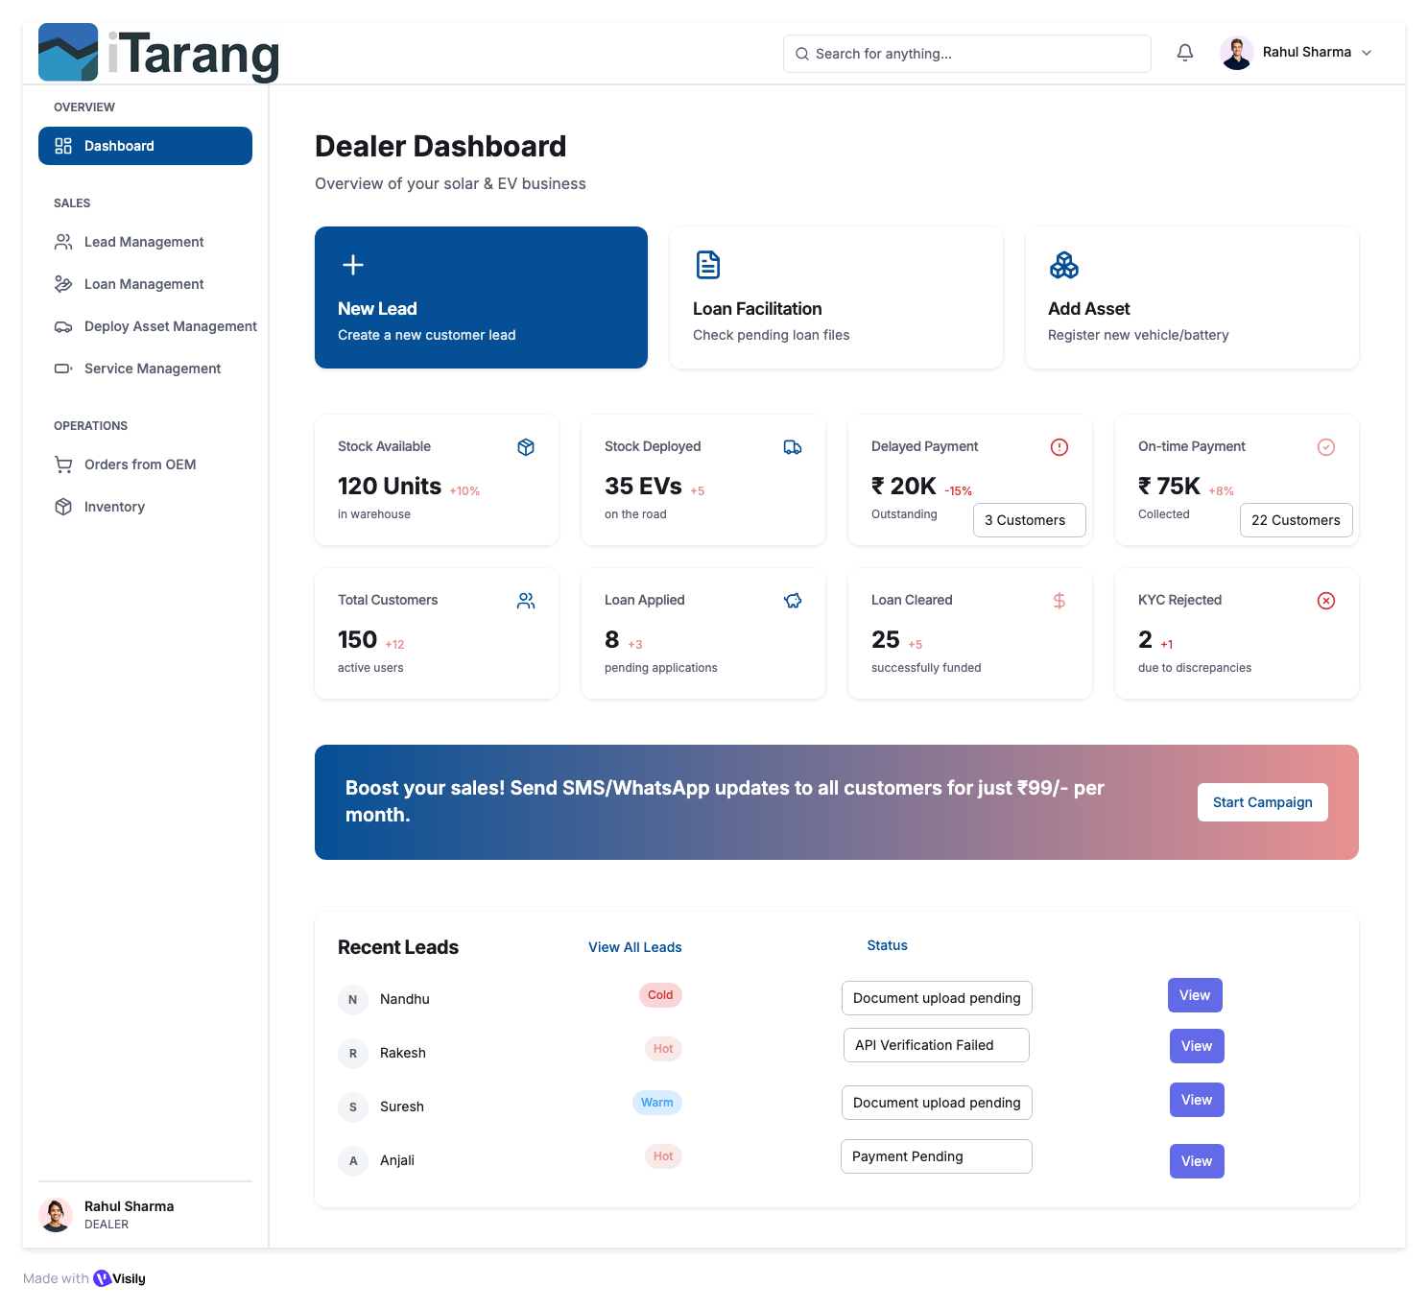

Create New Lead_Button Schema

Button Functions & User Interactions

Screen Overview
This is the first step in a 5-step workflow for creating a new lead in the iTarang CRM system. The screen collects personal information, product details, vehicle details, and lead classification data.
Workflow Position: Step 1 of 5
Reference ID Format: #IT-2026-0000001 (Auto-generated)
Generate reference: #IT-[YEAR]-[SEQUENCE]

Top Menu Action Buttons
Workflow Type: Multi-step transactional form
State: LEAD_DRAFT until final submission

- HEADER BUTTONS & ELEMENTS
Frontend:
Workflow Progress Bar
Type: Display-only component
Function
- Shows: Step 1 of 5
- Highlights current step
- Non-clickable

Backend:
- No API.
- Progress state derived from route /leads/create?step=1

- Info (ℹ️) Button
Frontend:
- On click → Open help modal
- Modal shows:
  - Required fields explanation
  - Loan compliance guidelines
  - Example formats
Backend: Static content or fetched: GET /api/help/lead-step-1
- Auto-fill from ID
Frontend
- Click → Open ‘Auto fill customer details pop up’ modal
- User click:
  - Aadhaar Front: To upload image in png, jpeg and PDF
  - Aadhaar Back: To upload image in png,jpeg and PDF
  - Start scanning: CALL API initiate OCR API, Both the uploaded images run through OCR and extract Name, Husband/Father Name, Date of Birth, Current Address
- Validation:
  - Add File Size & Format Validation
  - Max file size: 5MB per image
  - Allowed formats: PNG, JPEG, PDF
  - Image quality check (min 300 DPI recommended)
  - Show upload progress bar
  - OCR Error Handling
- What if OCR fails to extract data?:
  - Show error message: 'Could not read document. Please ensure image is clear'
  - Allow manual entry fallback
  - Retry option
  - Support for poor quality scans
Backend:
- POST /api/leads/autofillRequest: { idType: 'aadhaar|pan|customer|lead', idValue: 'string' }Response: { success: boolean, data: { fullName, fatherName, dob, address, phone, etc. }, message: string }

State Update:
- Overwrites matching fields
- Marks form as “Auto-filled”
- Logs audit event
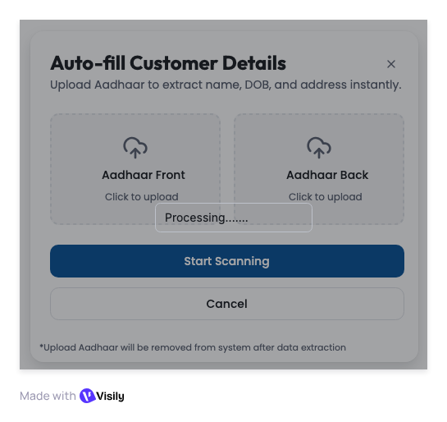

PERSONAL INFORMATION – FIELD WORKFLOW
All fields update local form state until save.

Full Name (Required)
Validation:
- 2–100 chars
- Letters + spaces + . -
- Auto-capitalize first letter of each word
- Validation: At least 2 characters
- Error message: 'Please enter a valid full name’, ‘No special characters except’
Frontend:
- Validate on blur
- Red border if invalid
Backend:
- Revalidated during submission
- Value syncs to form state

Father/Husband Name (Required for loan eligibility)
  - Same validation as Full Name.
  - If the product selected later requires a loan: → This becomes mandatory.

Date of Birth (Required)
Frontend:
- Calendar picker
- Age >= 18
- Show calculated age
Backend:
- Store ISO format

- Phone Number (Critical Field)
Frontend:
- Format: +91 XXXXX XXXXX
- Real-time validation
- AJAX duplicate check: GET /api/leads/check-duplicate?phone=9876543210
If duplicate:
- Show warning
- Provide "View Existing Lead" button
Backend:
- Store with +91
- Soft duplicate allowed (with warning log)

Current Address (Optional)
- Min 20 characters

- Permanent Address (Optional)
  - Min 20 characters
  - ☑ Same as Current: if checked ‘Auto copy’
Backend:
- Store boolean is_current_same

PRODUCT DETAILS – CONDITIONAL LOGIC
- Product Category (Required)
Fetch: GET /api/inventory/categories
Selection triggers:
- Load Product Types
- Determine if vehicle section visible

- Product Type (Required)
Fetch: GET /api/inventory/products?category=3-Wheeler
Must store:
- Product_Type ids
- Multiselect as per Product category
- Add 'Add Another Product' button to create multiple entries
- Consider: Primary product (required) + Secondary products (optional)
- If not in stock → show: “Order from OEM” suggestion

- VEHICLE DETAILS (Conditional Block)
  - Visible only if:Product category = 3W/2W/4W

- Vehicle Registration Number (Mandatory)
  - Auto uppercase’

- Vehicle Ownership
  - vehicle_registration_number IS NOT NULL
  - if the user fills Vehicle Reg. Number
    - Show validation: 'You've entered vehicle details
    - Automatically make dependent fields required: •
      - Vehicle Ownership (Required)
      - Owner Name (Required)
      - Owner Phone (Required)
    - Show asterisk (*) dynamically on these fields.
    - Add section heading: 'Existing Vehicle Information' (for context)
Dropdown:
- Self
- Financed
- Company
- Leased
- Family
Conditional fields appear based on selection.

- Owner Name
  - Name format same as ‘Full Name’.
  - vehicle_registration_number IS NOT NULL
  - if user fills Vehicle Reg. Number:
    - Show validation: 'You've entered vehicle details'
    - Automatically make dependent fields required:
      - Vehicle Ownership (Required)
      - Owner Name (Required)
      - Owner Phone (Required)
    - Show asterisk (*) dynamically on these fields
    - Add section heading: 'Existing Vehicle Information' (for context)
- Owner Phone
  - The phone format is the same as ‘Phone Number’.
  - vehicle_registration_number IS NOT NULL
  - if the user fills Vehicle Reg. Number:
  - Show validation:
    - 'You've entered vehicle details'
    - Automatically make dependent fields required:
      - Vehicle Ownership (Required)
      - Owner Name (Required)
      - Owner Phone (Required)
  - Show asterisk (*) dynamically on these fields
  - Add section heading: 'Existing Vehicle Information' (for context)
LEAD CLASSIFICATION
Hot / Warm / Cold (Required)
Frontend:
- Toggle group
- Must select one
Backend:
Stores:
- interest_level: hot | warm | cold
- lead_score: computed_value
Suggested scoring:
- Hot → 90
- Warm → 60
- Cold → 30
Triggers:
- Hot leads: 'Create Lead' saves Step 1 and auto-navigates to Step 2
- Warm/Cold: 'Create Lead' saves and exits workflow
PAYMENT METHOD
- Payment Method Dropdown (Required)
Options:
- Cash
- Other Finance (default)
- Dealer Finance
Frontend Logic
On change:
- If Cash:
  - Next page: Inventory Selection and Pricing
  - Skip intermediary steps
- If finance/Loan:
  - Show full Loan Documents section
- Required Docs = 11
Backend:
- PATCH /api/kyc/:leadId/payment-method
Store:
- payment_method = 'Cash' | 'Other finance' | ‘Dealer finance”
- loan_required = true/false
Return:
- Next Page Logic

BOTTOM BUTTONS – CORE LOGIC
- Create Lead
Purpose: Immediate save & exit workflow

Frontend:
- Validate all required fields
- If errors → highlight
- If valid → confirm modal:Create lead
- On confirm:
  - Disable button
  - Show spinner
  - Call API
Backend:
- POST /api/leads/create
Actions:
- Server-side validation
- Generate reference:
#IT-[YEAR]-[SEQUENCE]
- Set:
status = INCOMPLETE
workflow_step = 1
- Save to leads table
- Create activity log
- Trigger notifications if HOT
Response
{success: true,
leadId,
referenceId}
- After Success
- Toast: Lead created
- Redirect to:
/leads/:id

- Cancel

Frontend:

If form untouched: → Go back

If modified:→ Show confirmation modal

On confirm:
- Clear local state
- Delete draft if exists:
  - DELETE /api/leads/draft/:sessionId
  - Redirect to dashboard
STATE MANAGEMENT LOGIC
During Step 1:
- form_state = LOCAL
- lead_state = DRAFT (optional)
After Create Lead:
- lead_status = INCOMPLETE
- workflow_step = 1

Button | Frontend Action | Backend Action | State Change
info | Open modal | None | None
Auto-fill | Call autofill API | Return data | Populate form
Create Lead | Validate → POST | Insert Lead | incomplete
Cancel | Confirm → Navigate | Delete draft (optional) | Discard

Error Handling
For every API call and user action, specify:
  - Network errors: 'Connection lost. Please try again'
  - Validation errors: Field-specific error messages
  - Server errors (500): 'Something went wrong. Contact support'
  - Permission errors (403): 'You don't have permission'
  - Timeout errors: Retry mechanism with exponential backoff
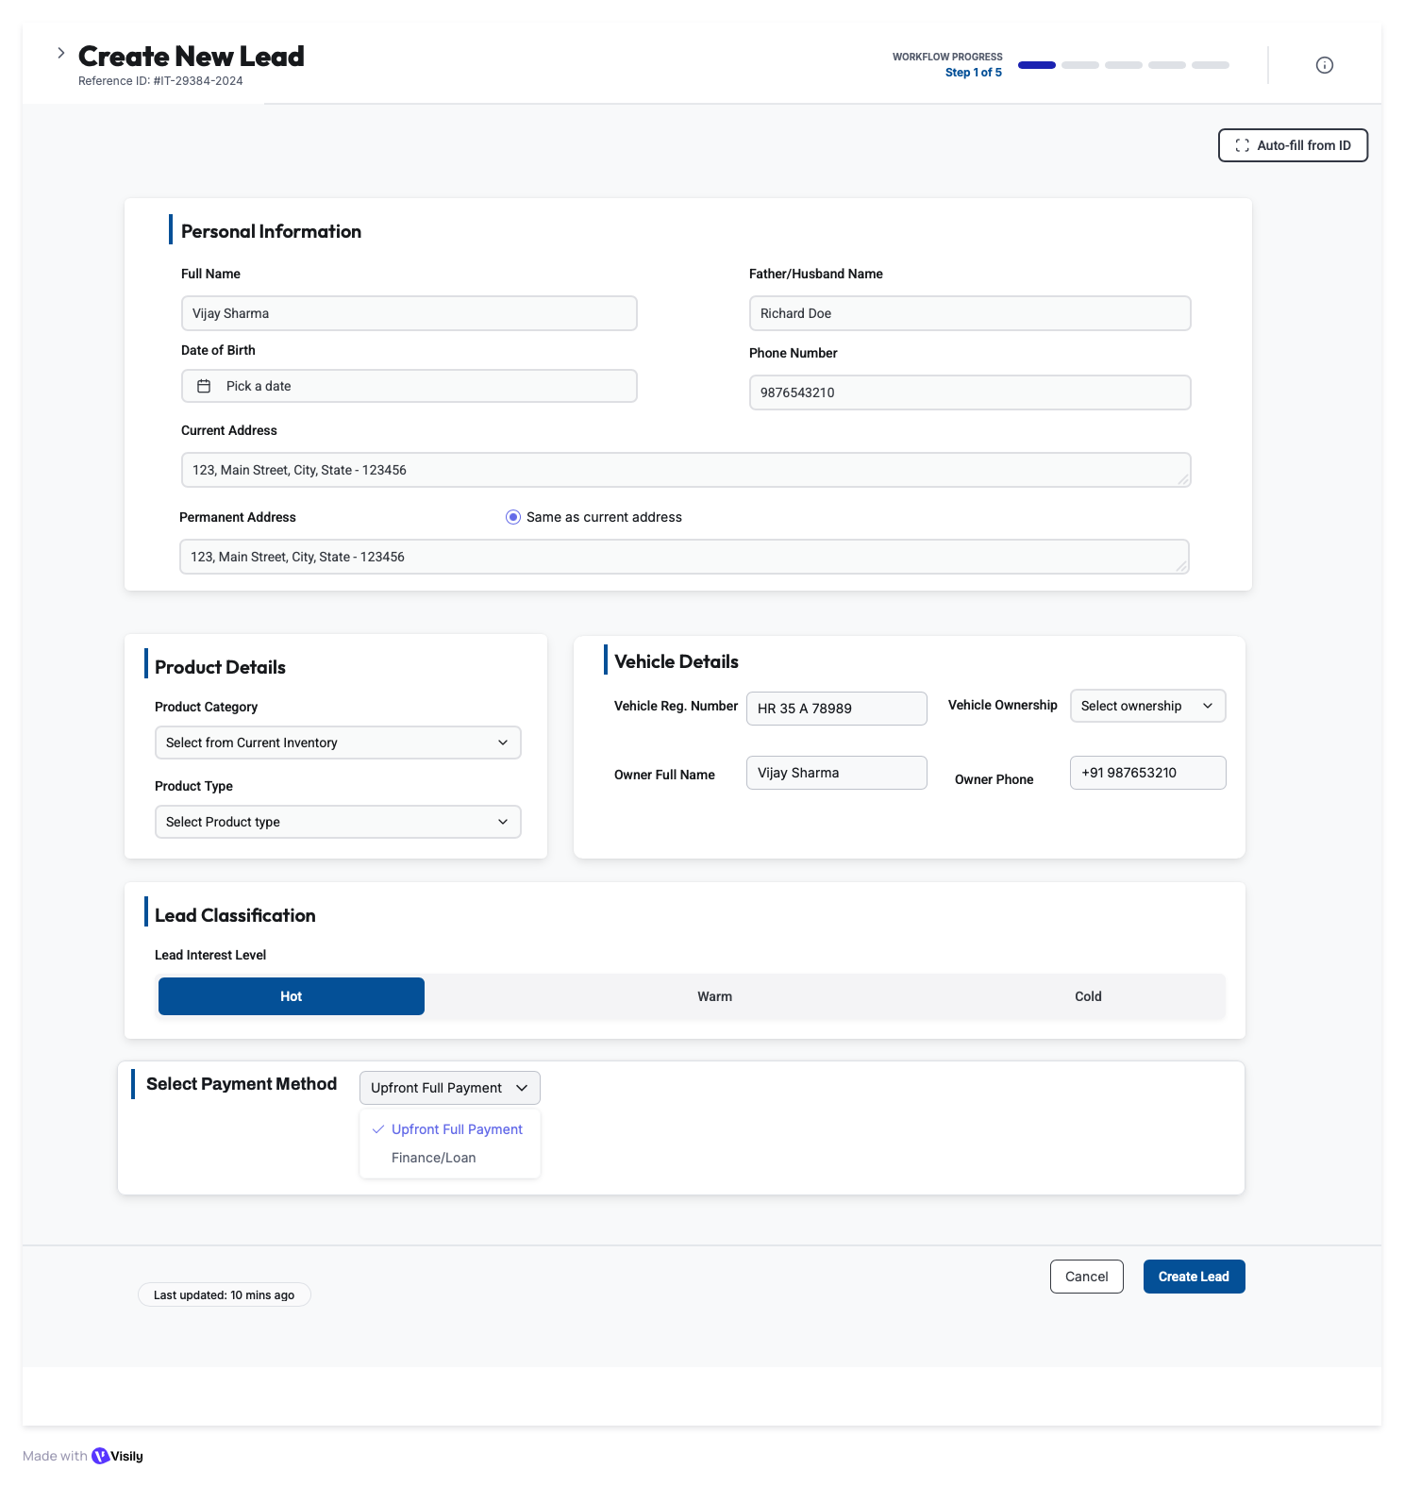

Customer KYC – Step 2 of 5 (Hot Lead Only)_Button Schema
SCREEN ACCESS LOGIC
Access Condition
- User can access Step 2 only if:

lead_created = true
AND interest_level = 'hot'
AND Payment_Method <> ‘Cash’

Backend Gatekeeper
- GET /api/kyc/:leadId/access-check
- If not allowed → redirect to the ‘Create Lead Page’

CUSTOMER CONSENT

DIGITAL CONSENT WORKFLOW (AADHAAR ESIGN)

Send SMS/WhatsApp Consent
Frontend:
Click button: Send SMS/WhatsApp Consent
Disable Generate Consent PDF button (mutually exclusive)
Show phone number confirmation modal
- On confirm:
  - Disable button, show spinner
  - Call API
- On success:
  - Show toast: 'Consent form sent to customer'
  - Update Consent Status: 'Link_sent (SMS/WhatsApp delivered)'

Backend:
POST /api/kyc/:leadId/consent/digital/send-link

Request Body:
{
leadId: "IT-2026-0000123",
customerPhone: "+919876543210",
channel: "whatsapp" | "sms"
}

Response:
{
success: true,
consentLinkId: "CL-20260726-001",
linkUrl: "https://itarang.com/consent/CL-20260726-001",
expiresAt: "2026-07-27T10:30:00Z",
deliveryStatus: "sent"
}

Database Updates:
- consent_status = 'link_sent'
- consent_link_sent_at = CURRENT_TIMESTAMP
- consent_link_expires_at = CURRENT_TIMESTAMP + INTERVAL 24 HOUR
- consent_link_url = generated_url
- consent_delivery_channel = 'whatsapp' | 'sms'
```

**SMS/WhatsApp Template:**
```
Hi {CustomerName},

iTarang requires your consent to process your loan application.

Click here to review and sign digitally:
{ConsentLink}

This link expires in 24 hours.
Uses Aadhaar-based eSign (100% secure)

Questions? Call 1800-XXX-XXXX
- Team iTarang

Link Expiry Handler:
Cron job runs every hour
If consent_link_expires_at < NOW AND consent_status = 'link_sent':
- Set consent_status = 'expired'
- Send notification to dealer: "Consent link expired for Lead #{leadId}"
- Show "Resend Consent" button in UI
Customer Completes Aadhaar eSign
Customer-Side Flow (External Page)
- Customer clicks consent link
- System records: consent_status = 'link_opened'
- Customer reviews consent text
- Clicks "Sign with Aadhaar"
- eSign provider (DigiLocker/NSDL/eMudhra) opens Aadhaar OTP screen
- System records: consent_status = 'esign_in_progress'
- Customer enters Aadhaar OTP
- eSign provider validates OTP with UIDAI
- eSign provider generates digitally signed PDF with:
  - Digital signature certificate
  - Timestamp
  - Aadhaar number (masked)
  - eSign transaction ID
eSign Provider Callback (Webhook):
POST /api/kyc/consent/esign/callback (called by eSign provider)
Request Body (from provider): { transactionId:"ESIGN-20260726-ABC123", status: "success" | "failed", signedPdfUrl: "https://esign-provider.com/signed/ABC123.pdf", signedAt: "2026-07-26T10:45:30Z", signerAadhaar: "XXXX-XXXX-3456",certificateId: "CERT-2026-XYZ", errorCode: null, errorMessage: null }
Backend Processing:
1. Validate webhook signature (security check)
2. Download signed PDF from provider URL
3. Store in iTarang permanent storage: -S3/Azure: /kyc/{leadId}/consent/signed_esign_{timestamp}.pdf
4. Extract and store metadata: - esign_transaction_id -esign_certificate_id - signed_pdf_url (iTarang storage) - signed_at - signer_aadhaar_masked - sign_method ='aadhaar_esign'
5. Update database: - consent_status = 'admin_review_pending' 🔶 - esign_completed_at =CURRENT_TIMESTAMP
6. Create admin task: - task_type = 'consent_review' - task_title = "Review Digital Consent - Lead #{leadId}" - assigned_to = 'consent_review_queue' - priority = 'high'
7. Send notifications: - Email to admin@itarang.com: "New consent pending review" - Dashboard alert for Admin users - SMS to dealer: "Customer signed consent, under review" Response to Provider: { success: true, received: true }
Failure Handling:

If eSign status = "failed"
consent_status = 'esign_failed'
- Store failure reason:
  - esign_error_code
  - esign_error_message (e.g., "Invalid OTP", "Aadhaar suspended")
- Send SMS to customer: "Consent signing failed. Reason: {error}. Click to retry: {link}"
  - Allow 3 retry attempts
  - After 3 failures:
    - consent_status = 'esign_blocked'
    - Notify dealer: "Customer eSign blocked, switch to manual consent”

Admin Reviews Digital Consent**
**Admin Console - Consent Review Queue:**
**Navigation:** ``` Admin Dashboard → Consent ReviewQueue ```
**Queue View (Table):**

Lead ID | Customer | Signed Via | Signed At | Status | Action
IT-2026-123 | Vijay Sharma | adhaar | 26-Jul 10:45 | Admin Review Pend. | Review
IT-2026-124 | Rakesh Kumar | Manual | 26-Jul 09:30 | Admin Review Pend. | Review

Filters:
- Status: All / Pending / Verified / Rejected
- Signed Method: All / Aadhaar eSign / Manual
- Date Range
- Dealer

**Review Screen (Click "Review" button):**
**Panel - Signed PDF Viewer:**

📄 Signed Consent PDF
[PDF Preview with zoom controls]

Digital Signature Verified
Certificate ID: CERT-2026-XYZ
Signed: 26-Jul-2026 10:45:30 AM
Signer Aadhaar: XXXX-XXXX-3456
[Download PDF] [Print]

[Admin Notes - Optional]

[❌ Reject] [✅ Approve & Verify]

Backend - Approve Action:

POST /api/kyc/:leadId/consent/admin/verify
Request Body: { leadId: "IT-2026-0000123", decision: "approved",reviewerNotes: "All details verified, signature valid", reviewerId: "ADMIN-001" }
Database Updates:
- consent_status ='admin_verified'
- consent_verified_by = 'ADMIN-001'
- consent_verified_at = CURRENT_TIMESTAMP
- consent_verification_notes = reviewer_notes
- consent_final = true
Audit Log: { action: "consent_verified", entity:"Lead", entity_id: "IT-2026-0000123", performed_by: "ADMIN-001", timestamp: "2026-07-26T11:00:00Z", details: {previous_status: "admin_review_pending", new_status: "admin_verified" } }

Notifications:
- Email to dealer: "Consent verified for Lead #{leadId}, ready for next step"
- SMS to customer: "Your consent has been verified. Next: Product selection"
- Update lead workflow_step gating

Backend - Reject Action:

POST /api/kyc/:leadId/consent/admin/reject

Request Body:
{
leadId: "IT-2026-0000123",
decision: "rejected",
rejectionReason: "mandatory" dropdown:
- "Signature mismatch"
- "Name mismatch with Aadhaar"
- "Incomplete consent text"
- "Expired certificate"
- "Fraudulent document suspected"
- "Other (specify in notes)",
reviewerNotes: "Customer name in PDF does not match lead record",
reviewerId: "ADMIN-001"
}

Database Updates:
- consent_status = 'admin_rejected'
- consent_rejected_by = 'ADMIN-001'
- consent_rejected_at = CURRENT_TIMESTAMP
- consent_rejection_reason = rejection_reason
- consent_rejection_notes = reviewer_notes

Trigger Re-Consent Flow:
- Send email to dealer: "Consent rejected for Lead #{leadId}. Reason: {reason}"
- SMS to customer: "Your consent could not be verified. Please re-sign: {new_link}"
- Generate new consent link with extended expiry (48 hours)
- Reset consent_status = 'link_sent'
- Increment consent_attempt_count
- If consent_attempt_count > 3:
  - Escalate to senior admin for manual handling

MANUAL CONSENT WORKFLOW (OFFLINE SIGNED PDF)

This is the fallback when digital consent fails or is unavailable.
Generate Consent PDF (Preview Only)
Frontend:
- Click button: Generate Consent PDF
- Disable Send SMS/WhatsApp Consent button (mutually exclusive)
- Show loading spinner
- Call API
Backend:
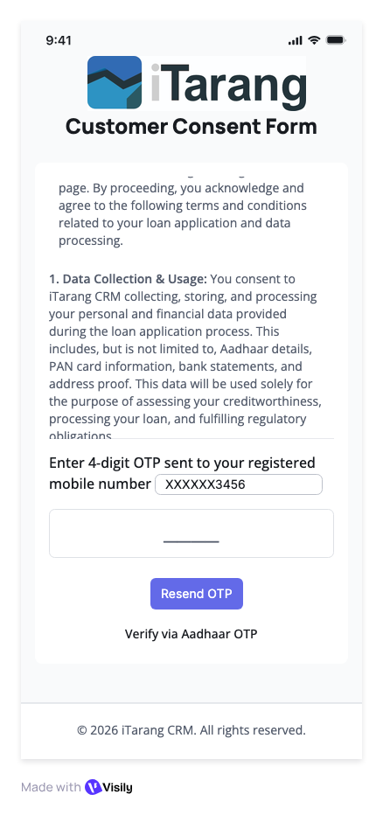
- 7. Return: { success: true, sentAt: timestamp }

Generate Consent PDF
Frontend:
- Click button: Generate Consent PDF
- Disable ‘Send SMS/WhatsApp Consent’
- Show loading spinner
- Call API
- On success:
  - Download PDF automatically
  - Show toast: 'Consent PDF downloaded'
  - Enable 'Upload signed consent PDF' button
- Keep Cancel button to restart
Backend:
- POST /api/kyc/:leadId/generate-consent-pdf
- Fetch lead data: Name, Father name, Address, Product details
- Generate PDF using template:
  - Header: Company logo, Consent form title
  - Body: Pre-filled customer details, loan terms, consent text
  - Footer: Signature fields (Customer, Witness, Date)
- Store PDF temporarily: /temp/consent_{leadId}.pdf
- Return: { success: true, pdfUrl: string, expiresIn: 3600 }PDF Template:
  - Library: pdf kit or puppeteer
  - Include: Consent text for credit check, loan agreement, data sharing
  - Signature boxes: Customer signature, Date, Witness signature, Customer Thumb Print

Upload Signed Consent PDF Button
Frontend:
- Enabled only after 'Generate Consent PDF' is clicked
- Click → Open file picker
- Accepted: PDF only
- Max size: 10MB
- Show upload progress.
- On success:
  - Update Consent Status: 'Manual Consent Uploaded'
  - Show preview thumbnail
  - Mark as asterisk (*) required field fulfilled
Backend:
- POST /api/kyc/:leadId/upload-signed-consent
- Payload: FormData { file: File }
- Validate: PDF format, size <10MB
- Upload to S3: /kyc/{leadId}/signed_consent.pdf
- Store URL: signed_consent_url
- Update: consent_status = 'manual_uploaded'
- Create verification task for admin: 'Review manual consent'
- Return: { success: true, fileUrl: string }

Consent Status Display
Overview: iTarang requires explicit customer consent for KYC data processing, credit checks, and loan facilitation. Consent can be obtained via:
- Digital Consent (Aadhaar eSign) - Preferred
- Manual Consent (Signed PDF upload) - Fallback
Critical Compliance Rule:
- All consents (digital or manual) MUST be reviewed and approved by iTarang Admin before lead can proceed to next step
- This ensures regulatory compliance and fraud prevention

CONSENT STATUS STATE MACHINE
Replace the simple status field with this comprehensive state machine:
- Digital consent Path
  - Awaiting_signature (default)
  - link_sent (SMS/WhatsApp delivered)
  - Link_opened (customer clicked link)
  - E-sign_in_progress (OTP stage active)
  - E-sign_completed (Aadhaar OTP verified)
  - Admin_review_pending (awaiting approval)
  - Admin_verified (FINAL - can proceed)
  - Admin_rejected (must re-consent)
  - Expired (link timeout - 24hrs)
- Manual consent Path
  - Consent_generated (preview downloaded)
  - Consent_uploaded (scanned copy received)
  - Admin_review_pending
  - Admin_verified (FINAL - can proceed)
  - Admin_rejected (reupload required)
Consent Gating Rule

Save & Next button enabled ONLY IF: consent_status IN ('admin_verified', 'manual_verified')

DOCUMENT UPLOAD CARDS
- (Only visible if payment_method <> ‘Cash’)
- Uploader

Common Upload Flow (All Document Cards)

Frontend:
- Click card
- Open file picker
- Validate type & size
- Show progress
- On success:
  - Green check
  - Thumbnail preview
  - Update count
Backend:
- POST /api/kyc/:leadId/upload-document
Payload:
- documentType: file
Store:
- File URL
- Uploaded timestamp
- Initial status = 'pending'
DOCUMENT-SPECIFIC LOGIC

Aadhaar Front & Back
- Required
- OCR extraction
- Cross-match name & DOB using API as per ‘https://decentro.tech/resources/identity-verification
- Cross-match address (Back) using API as per ‘https://decentro.tech/resources/identity-verification
- Cross-match Father/Husband Name using API as per ‘https://decentro.tech/resources/identity-verification
- Authenticate aadhar using API as per ‘https://decentro.tech/resources/identity-verification
- aadhaar_verification_status:
  - pending → in_progress → success | failed
  - Fail Reason to be specified as per ‘https://decentro.tech/resources/identity-verification
PAN Card
- Required
- Validate format
- Cross-check name with Aadhaar and using API as per ‘https://decentro.tech/resources/identity-verification PAN
- Cross-check DOB with Aadhaar and using API as per ‘https://decentro.tech/resources/identity-verification PAN
- Cross-check Father/Husband name with Aadhaar and using API as per ‘https://decentro.tech/resources/identity-verification PAN
- Authenticate PAN using API as per ‘https://decentro.tech/resources/identity-verification
- PAN_verification_status:
  - pending → in_progress → success | failed
  - Fail Reason to be specified as per ‘https://decentro.tech/resources/identity-verification
Passport Photo
- Required
- Face detection
- Min resolution check
- Cross-check photo with Adhaar using API as per ‘https://decentro.tech/resources/identity-verification
- If mismatch > 20% → Status = failed
- Photo Verification status:
  - pending → in_progress → success | failed
  - Fail Reason to be specified as per ‘https://decentro.tech/resources/identity-verification
Address Proof
- Required
- Fuzzy match with Current address
- <80% match → Status = failed
- Address Verification status:
  - pending → in_progress → success | failed
  - Fail Reason → Address mismatch with updated permanent address
RC Copy (Conditional)
- Required only if: Asset Category = 3W/2W/4W and != Inverter
- Verify authentication via VAHAN API using https://surepass.io/vahan-verification-api/
- Cross-check reg number and Owner Name mentioned before
- Authenticate RC using API as per https://surepass.io/vahan-verification-api/
- RC_verification_status:
  - pending → in_progress → success | failed
  - Fail Reason to be specified as per https://surepass.io/vahan-verification-api/
Bank Statement
- Required
- OCR to Read Beneficiary name, Account number, Bank, Branch, IFSC
- All details to be stored in a table
- Cross-check Beneficiary name with Customer Name
- Use Penny drop verification to authenticate account https://decentro.tech/resources/penny-drop-verification-api
- Bank Statement_verification_status:
  - pending → in_progress → success | failed
  - Fail Reason to be specified as per Beneficiary name mismatch and https://decentro.tech/resources/penny-drop-verification-api
Undated Cheques (4 Required)
Frontend:
- 4 slots mandatory
- Show progress: 3/4
Backend:
- OCR account number
- Ensure same account across cheques (Fail1)
- Ensure account matches with uploaded Bank document (Fail2)
- Bank Statement_verification_status:
  - pending → in_progress → success | failed
  - Fail Reason to be specified for
    - Fail1: Different cheques uploaded, please upload cheques for same account
    - Bank statement and cheques are not matching
DOCUMENT STATUS COUNTER
Status Display:
- Documents Uploaded: 09/11 - Shows count of completed uploads
- Documents Pending: PAN Card, Passport Size Photo - Lists missing docs in red text
- Auto-updates as user uploads documents
Backend Calculation:
GET /api/kyc/:leadId/document-statusResponse: { totalRequired: 11, uploaded: 9, pending: ['pan_card', 'passport_photo'], allComplete: false}

VERIFICATION ACTION

Coupon Code Field
Frontend:
- Text input field
- Placeholder: 'Enter verification coupon code'
- Max length: 20 characters
- Alphanumeric only
- Required

Backend:
- Validates coupon code against dealer specific assigned coupon codes API
- If valid: strike off and enable verification
- If invalid: Show error 'Invalid coupon code'
- Store: coupon_code, coupon_applied_at, coupon_status change to used

Validate Button
Frontend:
- Check if coupon code entered
- If empty: Show error 'Please enter coupon code’
- If filled:
  - Disable button
  - show spinner
  - Call validation API
- On success:
  - Show toast: 'Coupon validated
  - Enable 'Submit for Verification' button
- On failure:
  - Show error: 'Invalid coupon or expired'
  - Keep 'Submit for Verification' disabled
Backend:
- POST /api/kyc/validate-coupon
- Payload: { couponCode: string }
- Call API: Verify coupon
- If valid: Store coupon_available
  - Mark coupon as validated
- Return: { valid: boolean, creditsAvailable: number, message: string }

Submit for Verification Button
Trigger automated verification of Aadhaar, PAN, Bank via third-party APIs, Trigger Fetch API for CIBIL via Third Party Verification API

At the validation screen iTarang team can ask for other documents and those document requirements will be reflected in the Other Documents & Co-Borrower KYC Screen (Interim Step).

Frontend:
- Pre-check:
  - All required documents uploaded? (11/11)
- If not complete:
  - Show error: 'Please upload all required documents'
    - Highlight missing documents in red
- If complete:
  - Show confirmation modal:'Submit documents for verification?
- On confirm:
  - Disable button, show spinner
  - Call verification API
- On success:
  - Show toast: 'Verification initiated. Check the status below.'
  - Scroll to 'Verification Status' table
  - Auto-refresh status every 30 seconds
  - Send all the attachments and customer details for manual validation by iTarang internal team (Internal validation Dashboard connected to lead ID)
- On failure:
  - Show error message
    - Re-upload button

Backend:
- POST /api/kyc/:leadId/submit-verification
- Validate:
  - All required docs uploaded
  - Extract data from uploaded documents (OCR)
  - Call third-party APIs sequentially:
    - Aadhaar Verification:
      - API: DigiLocker or UIDAI API
      - Verify: Aadhaar number, Name, DOB, Address, Father/Husband Name
      - Update: aadhaar_verification_status = 'in_progress'
    - PAN Verification:
      - API: PAN Verification
      - Verify: PAN number, Name
      - Cross-check name with Aadhaar
      - Update: pan_verification_status = 'in_progress'
    - Bank Verification:
      - API: Penny drop or Bank statement parser
      - Verify: Account number, IFSC, Name
      - Update: bank_verification_status = 'in_progress'
    - Address Verification:
      - Compare: Aadhaar address vs Address proof
      - Fuzzy match score
      - Update: address_verification_status = 'in_progress'
    - RC Verification (if applicable):
      - API: VAHAN API
      - Verify: Registration number, Owner name
      - Update: rc_verification_status = 'in_progress'
    - Mobile Number Verification:
      - Send OTP to customer phone
      - Update: mobile_verification_status = 'awaiting_action'
  - Store verification_submitted_at = CURRENT_TIMESTAMP
  - Create webhook listeners for async API responses.
  - Return: { success: true, verificationsInitiated: 6, estimatedTime: '2-5 minutes' }
  - Disable upload/edit for that section until the admin responds.

Verification Status (Co-borrower) Table
Real-time display of document verification status from third-party APIs

Table Structure
Columns:
- Check - Verification type (Aadhaar, PAN, Bank, etc.)
- Status - Current verification state (badge/pill)
- Last Update - Timestamp of last status change
- Action - Re-upload button for failed verifications
- Failed Reason - Error message if verification failed

Status Values & Visual Indicators
• System initiating data fetch: Orange badge - Verification API called, waiting for response
• Awaiting action: Gray badge - Waiting for user action (e.g., OTP entry)
• Success: Green badge - Verification passed successfully
• Failed: Red badge - Verification failed - see reason
• Pending: Yellow badge - Verification in queue or processing

Individual Verification Rows
Aadhaar Verification
- Status: System initiating data fetch
- Last Update: 2024-07-26 10:30 AM
- Action: Re-upload
- Failed Reason:
Technical Details:
Frontend:
- Auto-updates via WebSocket or polling (every 10 sec)
- Shows spinner during 'initiating' state
Backend:
- Calls DigiLocker/UIDAI API/Decentro API
- Validates: Aadhaar number format, Name match, DOB match
- Updates status based on API response
- Possible outcomes: Success, Failed (name mismatch), Failed (invalid Aadhaar)
PAN Verification
- Status: Awaiting action
- Last Update: 2024-07-26 10:45 AM
- Action: Re-upload
- Failed Reason:
Technical Details:
Frontend:
- Gray badge indicates waiting state
- May require OTP or additional step
Backend:
- Calls Income Tax API or NSDL/Decentro API
- Validates: PAN format, Name match with Aadhaar
- If name mismatch:
  - Set status = Failed, reason = 'Name mismatch'
- If inactive PAN:
  - Set status = Failed, reason = 'PAN inactive or invalid'
Bank Verification
- Status: Awaiting action
- Last Update: 2024-07-26 10:45 AM
- Action: Re-upload
- Failed Reason:
Technical Details:
Frontend:
- May show 'Verify with Penny Drop' button
- Customer enters: Account number, IFSC code
Backend:
- Penny drop test: Deposit ₹1, verify account active
- parse bank statement for account details
- Validates: Account holder name matches customer name
- Checks: Account active, not frozen
Address Proof
- Status: Failed
- Last Update: 2024-07-26 10:45 AM
- Action: Re-upload
- Failed Reason: Address is not match
Technical Details:
Frontend:
- Red badge, Failed reason shown•
- ‘Re-upload' button enabled
- On click: Opens file picker to upload new address proofBackend:
  - Fuzzy match: Aadhaar address vs Address proof address•
  - If similarity <70%: Mark as Failed
  - Reason: 'Address mismatch. Please upload correct proof.'
  - Re-upload triggers new verification cycle
RC Verification
- Status: Failed
- Last Update: 2024-07-26 10:45 AM
- Action: Re-upload
- Failed Reason: Image Blur
Technical Details:
Frontend:
- Failed due to poor image quality
- 'Re-upload' button enabledBackend:
  - OCR quality check: Image clarity score
  - If score <60%: Mark as Failed, reason = 'Image blur or low quality'
- Calls VAHAN API to verify RC number
- Cross-checks: Owner name, Vehicle model
Mobile Number
- Status: Success
- Last Update: 2024-07-26 10:45 AM
- Action: Re-upload
- Failed Reason:
Technical Details:
Frontend:
- Green badge, verification complete
- OTP sent and verifiedBackend:
  - Sends OTP to customer's mobile
  - Customer enters OTP in modal/popup
  - Validates OTP within 5 minutes
  - On success: Mark as Success
  - On failure: Failed Reason

Re-upload Button Functionality
Frontend Workflow:
- Enabled only for 'Failed' status rows
- Click → Open file picker (specific to document type)
- Upload new document
- On success:
  - Reset status to 'Awaiting action'
  - Clear 'Failed Reason'
  - Show toast: 'Document re-uploaded
  - Verification will restart.'
- Auto-trigger verification for that specific document
Backend:
- POST /api/kyc/:leadId/re-upload
- Payload: { verificationType: 'aadhaar|pan|bank|etc', file: File }
- Delete old file from storage
- Upload new file
- Update: document_url, verification_status = 'awaiting_action'
- Re-trigger specific verification API
- Update: last_update = CURRENT_TIMESTAMP
- Return: { success: true, newStatus: 'awaiting_action' }

Consent Status Display (Top Right)
Current Display: 'Consent Status: Success' (Green badge)
This indicates the customer has completed consent (digital or manual).
Backend Logic:
- If consent_status = 'digitally_signed' OR 'manual_uploaded': Show 'Success'
  - If consent_status = 'link_sent': Show 'Pending'
  - If consent_status = 'awaiting_signature': Show 'Not Started'

Admin Review Outcomes
When iTarang reviews the documents, they have three simple outcomes per document:
- Verified
- Rejected – Need better clarity
- Request additional document (adds new doc type to list)
Frontend converts these into UI:
- Verified → Green tick
- Rejected → Red label with reason
- New doc request → New tile appears

Bottom Action Buttons
Back Button

Frontend:
- Check if any data is modified on current page
- If modified:
  - Show confirmation: 'You have unsaved changes. Go back?'
  - Options: 'Save Draft & Go Back' / 'Discard & Go Back' / 'Cancel'
- If 'Save Draft':
  - Call save draft API
  - Save the draft
- If 'Discard':
  - Clear form state.
  - Navigate to last saved form/draft
    - If draft save: PATCH /api/kyc/:leadId/draft { step: 2, data: {...} }

Save Draft Button
Frontend Workflow:
- Collect all form data:
  - Payment method
  - Uploaded documents (URLs)
  - Verification statuses
  - Consent status
  - Other documents
- Show loading spinner on button
- Call save draft API
- On success:
  - Show toast: 'Draft saved successfully'
  - Update 'Last updated' timestamp
  - Keep user on the same page
- On failure:
  - Show error: 'Failed to save draft. Please try again.
Backend:
- PATCH /api/kyc/:leadId/save-draft
- Payload: { step: 2, data: { paymentMethod, documents: {...}, verificationStatus: {...}, consent: {...} } }
- Update database: kyc_draft_data = JSON payload draft_saved_at = CURRENT_TIMESTAMP workflow_step = 2 kyc_status = 'draft'
- Return: { success: true, savedAt: timestamp }Auto-save:
  - Trigger auto-save every 2 minutes if user idle
  - Show subtle indicator: 'Auto-saved at HH:MM'

Save & Next Button (Conditional)
Condition: iTarant internal team has validated the document, all APIs has shown success or iTarang team has requested for other documents or iTarang team has requested for Co-Borrower details

Frontend Workflow:
- Validation checks:
  - ✓ Payment method selected
  - ✓ All required documents uploaded (11/11 if Finance, 3/11 if Upfront)
  - ✓ Consent obtained (Status = Success)
  - ✓ No critical verification failures
  - ✓ Internal validation success or Internal validation requested for other documentation and/or co-borrower information
- If validation fails:
  - Show error modal with checklist:
  - ❌ Missing: PAN Card upload ❌ Aadhaar verification failed ✓ Consent obtained
  - Highlight incomplete sections in red
  - Scroll to first error
  - Keep on same page
- If validation passes and no other documents and/or co-borrower information required:
  - Show confirmation: 'KYC data is complete. Proceed to Product Selection?'
    - On confirm:
      - Disable button, show spinner
      - Call save API
      - On success: Navigate to Step 3
      - On failure: Show error, re-enable button
- If validation passes and other documents and/or co-borrower information required:
  - Show confirmation: 'Other Documentation is required. Proceed to Next Page Selection?'
    - On confirm:
      - Disable button, show spinner
      - Call save API
      - On success: Navigate to Interim Step
      - On failure: Show error, re-enable button
Backend:
- POST /api/kyc/:leadId/complete-and-next
- Server-side validation:
  - Check: All required documents uploaded
  - Check: Consent status = 'digitally_signed' OR 'manual_uploaded'
- If validation fails:
  - Return: { success: false, errors: [...], missingItems: [...] }
- If validation passes:
  - Update lead status: kyc_status = 'completed' kyc_completed_at = CURRENT_TIMESTAMP workflow_step = 3
  - Calculate KYC score: kyc_score = ( (documents_uploaded / total_required) * 40 + (verifications_passed / total_verifications) * 40 + (consent_obtained ? 20 : 0) )
  - Store final KYC data: kyc_data = JSON { paymentMethod, documents, verifications, consent }
  - Create activity log: 'KYC completed for Lead #{leadId}'
  - Trigger notifications:
    - Email to dealer: 'KYC approved for {customer_name}'
    - SMS to customer: 'Your KYC is verified. Next: Select product.'
  - Return: { success: true, nextStep: 3, kycScore: 95, message: 'KYC completed successfully' }
- Frontend receives success:
  - Show success toast: 'KYC completed! Proceeding to product selection...'
  - Navigate to: /leads/:leadId/product-selection (Step 3)
  - Update progress bar: Step 3 of 5

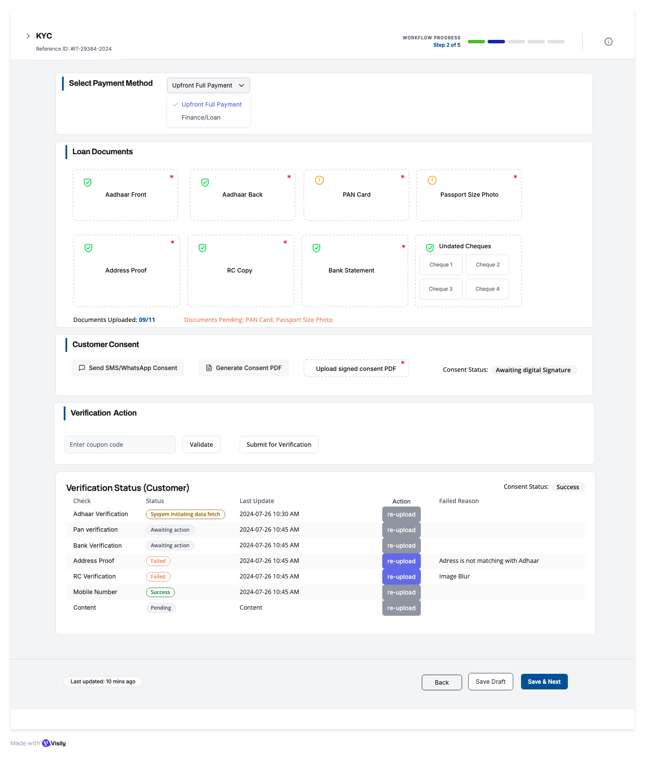

Other Documents & Co-Borrower KYC – Interim Step (Only If required by internal validation)_Button Schema

ACCESS LOGIC
This screen appears only if:
lead.has_additional_docs_required = true
OR
lead.has_co_borrower = true
Backend gatekeeper:
GET /api/kyc/:leadId/interim-access-check
If false → redirect to Step 3 accordingly.

- CO-BORROWER / GUARANTOR INFORMATION
Visible only when:
lead.has_co_borrower = true

Fields (8 total)
- Full Name
- Father/Husband Name
- Date of Birth
- Phone
- Permanent Address
- Current Address (+ checkbox “Same as permanent”)
- PAN
- Aadhaar
Validation
- Same as primary applicant KYC
- Age ≥ 18
- Co-borrower phone ≠ applicant phone
Auto-Fill from ID
Frontend
- Click → Open ‘Auto fill customer details pop up’ modal
- User click:
  - Aadhaar Front: To upload image in png, jpeg and PDF
  - Aadhaar Back: To upload image in png,jpeg and PDF
  - Start scanning: CALL API initiate OCR API, Both the uploaded images run through OCR and extract Name, Husband/Father Name, Date of Birth, Current Address
- Validation:
  - Add File Size & Format Validation
  - Max file size: 5MB per image
  - Allowed formats: PNG, JPEG, PDF
  - Image quality check (min 300 DPI recommended)
  - Show upload progress bar
  - OCR Error Handling
- What if OCR fails to extract data?
  - Show error message: 'Could not read document. Please ensure image is clear'
  - Allow manual entry fallback
  - Retry option
  - Support for poor quality scans
Backend
POST /api/leads/autofillRequest: { idType: 'aadhaar|pan|customer|lead', idValue: 'string' }Response: { success: boolean, data: { fullName, fatherName, dob, address, phone, etc. }, message: string }

State Update

Overwrites matching fields

Marks form as “Auto-filled”

Logs audit event


CO-BORROWER DOCUMENT UPLOAD (4 Required)

Document tiles (same as customer KYC):
- Aadhaar Front
  - Required
- Aadhaar Back
  - Required
- PAN Card
  - Required
- Passport Photo
  - Required
- Address Proof
  - Optional
- Bank Statement
  - Optional
  - 7–10. 4× Undated Cheques
- RC Copy (only if vehicle category is 2W/3W/4W)
  - Optional
Upload Flow
Frontend:
- Click tile → choose file
- Validate size/type
- Show upload progress
- Show green tick on success
Backend: POST /api/coborrower/:leadId/upload-document
Stores: url, doc_type, uploaded_at, status="pending"
Document Status Counter
API: GET /api/coborrower/:leadId/document-status
Displays:
- “Documents Uploaded: X/11”
- Pending list (e.g., PAN, Passport)
Progress bar → Success: Change to green checkmarkPENDING ALERT:Shows: 'Documents Pending: PAN Card, Passport Size Photo' in red/orange text
- CO-BORROWER CONSENT
Send SMS/WhatsApp Consent
Frontend:
- Click button:Send SMS/WhatsApp Consent
- Disable ‘Generate Consent PDF’ and ‘upload signed consent PDF’
- Validate: Customer phone number exists
- Prepare Consent Form with prefilled details
- Prepare consent form link to be sent on a registered mobile number
- Show confirmation modal: 'Send consent form link to +91-XXXXX-XXXXX?
- Show option to choose WhatsApp or SMS
- Cancel button on all screen
- On confirm:
  - Disable button
  - Show spinner
  - Call API
- On success:
  - Show toast: 'Consent form sent to customer'
  - Update Consent Status: 'Link Sent - Awaiting Response'

Backend:
- POST /api/coborrower/:leadId/send-consent
- Validate: leadId exists, phone number valid
- Generate consent document:
  - Header: Company logo, Consent form title
  - Body: Pre-filled customer details, loan terms, consent text
  - Footer: Signature fields (Customer, Aadhar OTP Verication ID, Date)
- Generate unique consent link: https://tarang.com/coborrowerconsent/{leadId}/{token}
- Send SMS via Twilio or other preferred method: 'Complete your loan consent: {link}. Valid for 24 hours. -iTarang
- Send WhatsApp message (if opted in)
- Store in database: consent_link_sent_at = CURRENT_TIMESTAMP consent_token = generated_token consent_status = 'link_sent'
- 7. Return: { success: true, sentAt: timestamp }


Generate Consent PDF
Frontend:
- Click button: Generate Consent PDF
- Disable ‘Send SMS/WhatsApp Consent’
- Show loading spinner
- Call API
- On success:
  - Download PDF automatically
  - Show toast: 'Consent PDF downloaded'
  - Enable 'Upload signed consent PDF' button
- Keep Cancel button to restart
Backend:
- POST /api/coborrower/:leadId/generate-consent-pdf
- Fetch lead data: Name, Father name, Address, Product details
- Generate PDF using template:
  - Header: Company logo, Consent form title
  - Body: Pre-filled customer details, loan terms, consent text
  - Footer: Signature fields (Customer, Witness, Date)
- Store PDF temporarily: /temp/consent_{leadId}.pdf
- Return: { success: true, pdfUrl: string, expiresIn: 3600 }PDF Template:
  - Library: pdfkit or puppeteer
  - Include: Consent text for credit check, loan agreement, data sharing
  - Signature boxes: Customer signature, Date, Witness signature, Customer Thumb Print

Upload Signed Consent PDF Button
Frontend:
- Enabled only after 'Generate Consent PDF' is clicked
- Click → Open file picker
- Accepted: PDF only
- Max size: 10MB
- Show upload progress.
- On success:
  - Update Consent Status: 'Manual Consent Uploaded'
  - Show preview thumbnail
  - Mark as asterisk (*) required field fulfilled
Backend:
- POST /api/coborrower/:leadId/upload-signed-consent
- Payload: FormData { file: File }
- Validate: PDF format, size <10MB
- Upload to S3: /kyc/{leadId}/signed_consent.pdf
- Store URL: signed_consent_url
- Update: consent_status = 'manual_uploaded'
- Create verification task for admin: 'Review manual consent'
- Return: { success: true, fileUrl: string }

Consent Status Display
Status Values:
- 'Awaiting digital Signature' - Default state, no action taken
- 'Link Sent - Awaiting Response' - SMS/WhatsApp sent, waiting for customer
- 'Digitally Signed' - Customer completed e-signature
- 'Manual Consent Uploaded' - Offline signed PDF uploaded
- 'Verified' - Admin approved the consent

- VERIFICATION ACTION

Coupon Code Field
Frontend:
- Text input field
- Placeholder: 'Enter verification coupon code'
- Max length: 20 characters
- Alphanumeric only
- Required

Backend:
- Validates coupon code against dealer specific assigned coupon codes API
- If valid: strike off and enable verification
- If invalid: Show error 'Invalid coupon code'
- Store: coupon_code, coupon_applied_at, coupon_status change to used

Validate Button
Frontend:
- Check if coupon code entered
- If empty: Show error 'Please enter coupon code’
- If filled:
  - Disable button
  - show spinner
  - Call validation API
- On success:
  - Show toast: 'Coupon validated
  - Enable 'Submit for Verification' button
- On failure:
  - Show error: 'Invalid coupon or expired'
  - Keep 'Submit for Verification' disabled
Backend:
- POST /api/kyc/validate-coupon
- Payload: { couponCode: string }
- Call API: Verify coupon
- If valid: Store coupon_available
  - Mark coupon as validated
- Return: { valid: boolean, creditsAvailable: number, message: string }

Submit for Verification Button
Trigger automated verification of Aadhaar, PAN, Bank via third-party APIs

Frontend:
- Pre-check:
  - All required documents uploaded? (4/4)
- If not complete:
  - Show error: 'Please upload all required documents'
    - Highlight missing documents in red
- If complete:
  - Show confirmation modal:'Submit documents for verification?
- On confirm:
  - Disable button, show spinner
  - Call verification API
- On success:
  - Show toast: 'Verification initiated. Check the status below.'
  - Scroll to 'Verification Status' table
  - Auto-refresh status every 30 seconds
  - Send all the attachments and customer details for manual validation by iTarang internal team (Internal validation Dashboard connected to lead ID)
- On failure:
  - Show error message
    - Re-upload button

Backend:
- POST /api/coborrower/:leadId/submit-verification
- Validate:
  - All required docs uploaded
  - Extract data from uploaded documents (OCR)
  - Call third-party APIs sequentially:
    - Aadhaar Verification:
      - API: DigiLocker or UIDAI API
      - Verify: Aadhaar number, Name, DOB, Address, Father/Husband Name
      - Update: aadhaar_verification_status = 'in_progress'
    - PAN Verification:
      - API: PAN Verification
      - Verify: PAN number, Name
      - Cross-check name with Aadhaar
      - Update: pan_verification_status = 'in_progress'
    - Bank Verification:
      - API: Penny drop or Bank statement parser
      - Verify: Account number, IFSC, Name
      - Update: bank_verification_status = 'in_progress'
    - Address Verification:
      - Compare: Aadhaar address vs Address proof
      - Fuzzy match score
      - Update: address_verification_status = 'in_progress'
    - RC Verification (if applicable):
      - API: VAHAN API
      - Verify: Registration number, Owner name
      - Update: rc_verification_status = 'in_progress'
    - Mobile Number Verification:
      - Send OTP to customer phone
      - Update: mobile_verification_status = 'awaiting_action'
  - Store verification_submitted_at = CURRENT_TIMESTAMP
  - Create webhook listeners for async API responses.
  - Return: { success: true, verificationsInitiated: 6, estimatedTime: '2-5 minutes' }
  - Disable upload/edit for that section until the admin responds.

Verification Status (Co-borrower) Table
Real-time display of document verification status from third-party APIs. Table structure is dynamic, as per uploaded documents.

Table Structure
Columns:
- Check - Verification type (Aadhaar, PAN, Bank, etc.)
- Status - Current verification state (badge/pill)
- Last Update - Timestamp of last status change
- Action - Re-upload button for failed verifications
- Failed Reason - Error message if verification failed

Status Values & Visual Indicators
• System initiating data fetch: Orange badge - Verification API called, waiting for response
• Awaiting action: Gray badge - Waiting for user action (e.g., OTP entry)
• Success: Green badge - Verification passed successfully
• Failed: Red badge - Verification failed - see reason
• Pending: Yellow badge - Verification in queue or processing

Individual Verification Rows
Aadhaar Verification
- Status: System initiating data fetch
- Last Update: 2024-07-26 10:30 AM
- Action: Re-upload
- Failed Reason:
Technical Details:
Frontend:
- Auto-updates via WebSocket or polling (every 10 sec)
- Shows spinner during 'initiating' state
Backend:
- Calls DigiLocker/UIDAI API/Decentro API
- Validates: Aadhaar number format, Name match, DOB match
- Updates status based on API response
- Possible outcomes: Success, Failed (name mismatch), Failed (invalid Aadhaar)
PAN Verification
- Status: Awaiting action
- Last Update: 2024-07-26 10:45 AM
- Action: Re-upload
- Failed Reason:
Technical Details:
Frontend:
- Gray badge indicates waiting state
- May require OTP or additional step
Backend:
- Calls Income Tax API or NSDL/Decentro API
- Validates: PAN format, Name match with Aadhaar
- If name mismatch:
  - Set status = Failed, reason = 'Name mismatch'
- If inactive PAN:
  - Set status = Failed, reason = 'PAN inactive or invalid'
Bank Verification
- Status: Awaiting action
- Last Update: 2024-07-26 10:45 AM
- Action: Re-upload
- Failed Reason:
Technical Details:
Frontend:
- May show 'Verify with Penny Drop' button
- Customer enters: Account number, IFSC code
Backend:
- Penny drop test: Deposit ₹1, verify account active
- parse bank statement for account details
- Validates: Account holder name matches customer name
- Checks: Account active, not frozen
Address Proof
- Status: Failed
- Last Update: 2024-07-26 10:45 AM
- Action: Re-upload
- Failed Reason: Address is not match
Technical Details:
Frontend:
- Red badge, Failed reason shown•
- ‘Re-upload' button enabled
- On click: Opens file picker to upload new address proofBackend:
  - Fuzzy match: Aadhaar address vs Address proof address•
  - If similarity <70%: Mark as Failed
  - Reason: 'Address mismatch. Please upload correct proof.'
  - Re-upload triggers new verification cycle
RC Verification
- Status: Failed
- Last Update: 2024-07-26 10:45 AM
- Action: Re-upload
- Failed Reason: Image Blur
Technical Details:
Frontend:
- Failed due to poor image quality
- 'Re-upload' button enabledBackend:
  - OCR quality check: Image clarity score
  - If score <60%: Mark as Failed, reason = 'Image blur or low quality'
- Calls VAHAN API to verify RC number
- Cross-checks: Owner name, Vehicle model
Mobile Number
- Status: Success
- Last Update: 2024-07-26 10:45 AM
- Action: Re-upload
- Failed Reason:
Technical Details:
Frontend:
- Green badge, verification complete
- OTP sent and verifiedBackend:
  - Sends OTP to customer's mobile
  - Customer enters OTP in modal/popup
  - Validates OTP within 5 minutes
  - On success: Mark as Success
  - On failure: Failed Reason

Re-upload Button Functionality
Frontend Workflow:
- Enabled only for 'Failed' status rows
- Click → Open file picker (specific to document type)
- Upload new document
- On success:
  - Reset status to 'Awaiting action'
  - Clear 'Failed Reason'
  - Show toast: 'Document re-uploaded
  - Verification will restart.'
- Auto-trigger verification for that specific document
Backend:
- POST /api/coborrower/:leadId/re-verify
- Payload: { verificationType: 'aadhaar|pan|bank|etc', file: File }
- Delete old file from storage
- Upload new file
- Update: document_url, verification_status = 'awaiting_action'
- Re-trigger specific verification API
- Update: last_update = CURRENT_TIMESTAMP
- Return: { success: true, newStatus: 'awaiting_action' }

Consent Status Display (Top Right)
Current Display: 'Consent Status: Success' (Green badge)
This indicates the customer has completed consent (digital or manual).
Backend Logic:
- If consent_status = 'digitally_signed' OR 'manual_uploaded': Show 'Success'
  - If consent_status = 'link_sent': Show 'Pending'
  - If consent_status = 'awaiting_signature': Show 'Not Started'

Other Documentation Upload (Dynamic Requests)
Appears only if iTarang team requested additional documents:
Backend returns a list: GET /api/coborrower/:leadId/required-other-docs
required_other_docs: [
{ id: 'rent_agreement', label: 'Rent Agreement', required: true },
{ id: 'owner_verification', label: 'Owner Verification', required: true }
]
Frontend (Step 3) will automatically:
- Show the “Other Documentation” section only if this list > 0.
- Display each required document as a separate tile with (dynamic tile):
  - Label
  - Upload button
  - Status indicator (Not Uploaded / Uploaded / Rejected / Verified)

Uploading Other Doc(Simple Rule)
Each dynamic tile works like this:
Frontend:
- Click tile → Upload file
- Validate file
- Show thumbnail
- Update status to: uploaded
Backend:
POST /api/coborrower/:leadId/upload-other-document
Store:
- file_url
- doc_type
- uploaded_at
- status = 'uploaded'
iTarang can also suggest for co-borrower information, if itarang selects co-borrower information, the next Section will be visible.

Submit for Verification Button
Frontend:
- Check: All required documents are uploaded in 'Other Documentation'
- If less: Show error 'Please upload all documents'
- If uploaded:
  - Show confirmation: 'Submit documents for review?'
  - On confirm: Call API4.
- On success:
  - Show toast: 'Documents submitted for review'
  - Disable further uploads until reviewed
Backend:
- POST /api/coborrower/:leadId/submit-other-docs-review
- Mark: other_docs_status = 'pending_review'
- Create admin task: 'Review other documents for Lead #{leadId}'
- Notify admin via email and dashboard
  - Return: { success: true, reviewStatus: 'pending' }
- Admin verifies all the attached documents, if approved
  - Return: { reviewStatus: 'Verified' }
- If Rejected
  - Return: { reviewStatus: ‘Rejected’, RejectedReason: ’as per admin comments’ }

Admin Review Outcomes
When iTarang reviews the documents, they have three simple outcomes per document:
- Verified
- Rejected – Need better clarity
- Request additional document (adds new doc type to list)
Frontend converts these into UI:
- Verified → Green tick
- Rejected → Red label with reason
- New doc request → New tile appears

- BOTTOM ACTION BUTTONS

Back
If data changed:
- Save Draft & Go Back
- Discard & Go Back
- Cancel

Save Draft
Saves full interim step state.
Backend: PATCH /api/coborrower/:leadId/save-draft
Stores:
- co-borrower info
- uploaded docs
- consent status
- verification status
- other documents
- Draft_saved_at
Auto-save every 2 minutes.
Preview Customer Profile (Primary Action)
This is the continue button for the interim step.
Pre-check:
✓ Co-borrower flow completed (if required)
✓ Other documents uploaded (if required)
✓ No pending verification failures
✓ Consent complete
If OK → proceed to preview.
Backend: POST /api/coborrower/:leadId/complete-and-preview
Updates:
- interim_step_status = "completed”
- workflow_step = 3
Redirect: /leads/:leadId/profile-preview

END-TO-END INTERIM FLOW SUMMARY
- Screen loads after automated KYC if additional checks needed
- User fills co-borrower info (if required)
- Uploads co-borrower’s 11 KYC docs
- Completes consent (digital or manual)
- Submits for automated verification
- Fixes failures (Edit → re-upload)
- Uploads additional documents requested by internal team
- Submits other docs for review
- Saves draft anytime
- Clicks Preview Customer Profile → moves to next step
